From nub to OP: How to improve your performance in competitive matches.

Preliminaries and glossary

This guide aims to help you to perform better in competitive matches in the lobby, including rated 1v1 and 4v4 TGs.

OP = overpowered, good, strong
Nub = noob, weak, bad, but can also be used ironically by good players
Eco = economy, resource gathering
Spec = spectators; observers; people who watch instead of playing.
Balance = in a 4v4 game, both teams have to be approximately equal in strength for the game to be enjoyable. Therefore it is important to have a mix of OP and nub players in each team so that any one side cannot win easily.
Pos = position on a map. Consider the minimap as a clock, tell your enemies your corresponding position on that clock so they can work out roughly where you are. Alternatively, you can use the flare tool to indicate your location.
Pocket: in a 4v4 on Mainland, the players will be scattered in equidistant intervals along circumference of the circular map, where the allies are grouped together. The pocket players are the 2 players whose neighbours are all allies. Pocket players are expected to support their flank players.
Flank = the players who are situated next to an enemy.
gg = say this at the end of a game when you think the outcome has been decided. The losing players will resign when gg is said.
Pop? = population. An indicator of how well you are doing.
Civ? = civilisation, faction
CC = civic centre; Agora
Cav = cavalry; horses
Inf = infantry units
DDOS = distributed denial of service attack, often takes the form of all players losing connection to the host and the host dropping offline, subsequently ending the game mid-way. In a severe case, the host’s home may lose internet connection for approximately 30 minutes.
Kick = invoked by command ‘/kick <playername>’ , used to kick a spec who is lagging.
Muted = using profanity (swearing) in the lobby results in the player being silenced from typing in the public lobby for some time.
Rating = the number next to your name which is intended to indicate your skill level. New players start as unrated (no number next to their name) and will gain a rating when they finish a rated match. The algorithm assumes all unrated players to be 1200. Winning against higher rated players will give you more increase in rating. Losing to lower rated players will deduct more ratings from you. I am a 1500-1600 player.
Rated game = a 1v1 game whose outcome will change your rating. There will be a red comment at the bottom right of your screen to indicate if the game is rated. YOU MUST RESIGN OR WAIT FOR YOUR ENEMY TO RESIGN BEFORE LEAVING SUCH A GAME. QUITTING WITHOUT RESIGNING WILL RESULT IN SANCTIONS FROM WFG DEVELOPERS.
Smurf = people who create multiple accounts then report false ratings, with the intention of looking for easy wins or ruining the balance in a TG as a form of trolling.

Match Settings

- Map: Mainland (found in map type=random).
- The biome is often temperate or Subalpine. At times the host may choose weird biomes, in which case, just signal them ‘nub biome’.
- Map size: medium for 3v3 and 4v4; Normal map for 1v1, 2v2. Some 1v1s can take place on Small maps.
- Starting resources: Low (300).
- Win mode: Conquest (kill all your enemy’s units and destroy or capture their every last building to win.)
- No revealed map
- No explored map
- Cheats disabled
- No treasure
- No nomad (sometimes nomad is fine for a fun game)
- No ceasefire
- Population: for 4v4 it is 200 each to reduce lag. For 1v1 it can be 200, 250 or 300 as negotiated.

Macro Aims:
These are the big things you should aim to achieve in every game to win.

- M1. Produce a higher population to strengthen your army and economy.
- M2. Phase up to city phase as early as possible to unlock siege weapons, highest tier techs, champion units and heroes.
- M3. High K/D ratio - less economic cost and greater strategic advantage.
- M4. Control resources - so that your enemy will be poor.
- M5. Know your enemy - keep a good eye on them by scouting so that you are prepared for any tricks up their sleeves.
- M6. Research technology. Eco techs allow you to use less number of units to gather resources at the same rate - more units can be fielded into battle. Military techs ensure that your units are stronger than your enemy’s units so that you are more likely to prevail in confrontations.
- M7. Defensive base layout - so that your enemy cannot harm you easily.

Common Strategies:
You can combine any of these strategies in a game as you need.

- Boom:
This is the most common strategy of focusing on pumping out the most units quickly and reaching P3 early, then commit every unit to a full scale attack which will likely destroy the enemy. Generally, in a mass scale battle, the side with more units and better quality units will often win. Therefore it is important to concentrate everything you have to fight at 1 point.

- Rush:
The opposite of boom; prioritising smaller-scale early aggressions to weaken the enemy.
Rushes can take various forms, but the earlier you rush, the better. The most common types of rush are early cavalry rush with 5-20 cavalry units and ranged infantry rush with some javelineers or slingers. Rushing will slow down your boom and leave your base undefended, which is a trade-off.

- Turtle:
Fortify your base then focus on economy and researching technologies instead of actively attacking your enemy. Wait for your enemy to attack you then decimate the invasion force with your more upgraded army and better position. When your enemy struggles with eco and cannot produce units efficiently, commit to a full scale attack with your elite force.

- P2 Push:
If you discover that your enemies are building in front of their CC or are extending their territory towards you, you can commit to a full scale attack in town phase with all infantry you have then retreat after you have done enough damage. You can do this with any citizen soldier you already have or mercenary units. The purpose of this attack is to prevent them from reaching city phase before you and damage their economy; if done well then it could be a gg. However, it is extremely risky as you must have more infantry than your enemy and you cannot afford to lose too many units in such an attack otherwise your eco is gone.

- Raiding
Using large numbers of cavalry, often involving mercenary cavalry and champion cavalry, to raid enemy bases and kill their worker units. Champion melee cavalry can also be used to outflank the enemy in a battle and decimate their ranged units from behind. However, this is a strategy used in team games to weaken all of your enemies simultaneously instead of 1v1 as the cavalry needs time to be produced.

- Siege tower troll:
Spamming a large number of siege towers and garrison them with 10 infantry each and send them into enemy base. Arrows from siege towers have a crush damage so they will annihilate all units and buildings of the enemy quite swiftly. Furthermore, siege towers are immune to ranged units so the soldiers inside are well protected. However, they are vulnerable to enemy melee units.

A general build order for booming with any civ: (assuming standard settings)
Within the first 10 seconds:
- Queue up 3 women in the CC in one BATCH.
- Send the 4 women to gather berries.
- Send 4 men to gather wood. If there is wood near your CC then collect those first, otherwise, build a storehouse near a large woodline and collect from there.
- Send the cavalry to hunt chickens.

- When the 3 women have been trained, send them to build a farmstead near the berries and queue up 3 more in the CC.
- When these 3 have been trained, task them to build a house. If you don’t have enough wood, then make them gather wood. Meanwhile queue up 3 more.
- Keep sending the newly trained women to gather wood or build houses.
- Queue up 2 more in a batch, make sure your first house is completed before these 2 emerge from the CC.
- From now on until 30 population, keep training as many women as you can afford in a batch, and build another house as soon as you gather enough wood. At 30 pop, send the new women from CC to build farms then farm on it. Make sure 5 farms have been constructed and in operation before you run out of berries.
- Watch out for housing issues. I recommend having 2 dedicated house builders to just build house after house so that you always have enough population capacity to train freely.
- If the cavalry finishes the chickens, use him to scout or hunt. You can build a storehouse near a big group of hunt. In this case the cavalry would provide much food income and you can use less farms.
- When the berry women finish their berries, send them onto farms as well. You should have 25 women working on farms in total by this point, everyone else is on wood.
- As soon as you can afford a barrack, send 4 women to build it.
- Research woodcutting and farming upgrades from storehouses when you can afford.
- When the barrack finishes, send the 4 women to farm or wood depending on whichever one you need more. Keep training ranged units from it, then send these to wood.
- If you are running low on food, divert 5 women at a time off your wood and make them build farms then do farming.
- When you have spare wood, build second barracks. By this point you should have at least 7 fields.
- Produce only men from the CC if you have enough wood; divert women to farms if you run low on food.
- At minute 8, send the new infantry to mining. Start producing melee infantry as well, from both CC and barracks.
- When you can afford it, click up to Town phase. But never stop training. Use the spare resources to go to Town phase.
- As soon as you reach town phase, send the newly trained units to build 2 blacksmiths and 1 market. Keep the mining operation going and research mining techs if you have spare food.
- Once the 3 buildings have been constructed, click up to P3. If you can’t afford it, barter food and wood for metal and stone. Aim to click down the III button before 12:00.
- On the way to city phase, build more barracks near your front line to supply yourself with soldiers; research military upgrades in the forges and keep training units.
- If you reach full population, start deleting women to free up space for more infantry and siege weapons. In total, I recommend having 7 infantry barracks. Cavalry stables are optional but if you think you have enough food then you can build 1-6 cavalry stables and add some cav units into your war effort.
- When you reach P3, build siege workshop immediately and produce rams from it. Elephant civs can use elephants instead. Also get hero trained.
- Then you can attack, but attack with everything you have, not just a trickle of units. I recommend fielding at least 110 units into a battle; use formations to keep them together. Close and Box are the most common ones.

Micro:
Micro-management helps you to achieve your macro aims. These are small things but are very significant when you add them up. Micro skills separate nubs from OPs.

Key things you want to avoid:

- Idle time. Don’t let your units stand still and do nothing. Always make them build or gather something, even if you think you have plenty of that resource. Don’t let production buildings (barracks, stables, civic centres) rest neither, always train something from each and every one of them, even if it means unit at a time. Also try to prevent your units from walking long distances; all of the walking time is wasted. This means squeezing in storehouses into your wood line whenever you see a large enough gap, and building farmsteads near berries or hunt. NEVER CHEAP OUT ON STOREHOUSES.

- Floating resources. Try to spend everything you have gathered, don’t let resources pile up. If you have too much wood and not enough food, move your wood women to farms. Similarly, if you are playing a heavy cavalry game, it’s ok to have 12 fields but very few units mining.
- Misuse of units. Units are specialised when it comes to resource gathering. Male infantry are best at mining and gathering wood, but are very slow at farming. Women are good at gathering food and wood, but are very slow at mining. Cavalry can gather hunt quickly. So never use women for mining and soldiers for farming. The only exception is if you are playing a special strategy that specifically requires spearmen on farms for defence against spear cav.

- Suicide. Don’t allow your units to walk into a battle one by one, because your enemy can just pick them of one by one. Instead, put all units into a formation at some distance away from the enemy, then control+right click on an enemy unit to attack move. The cohesion of the formation will dissipate incoming enemy projectile and reduce casualties. Also, don’t charge at a defence tower or walls. Avoid fighting too close to a CC or fortress or tower, especially when you have many ranged units. If you feel that you are losing a battle and the enemy clearly outnumbers you, then retreat immediately. Fighting an outnumbered battle will give you few kills at the cost of losing your entire army.

Formation vs no formation:
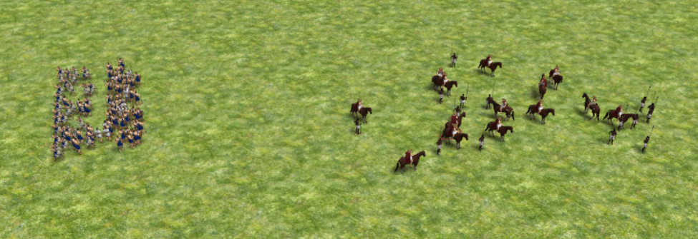

- Not researching techs. All of the military techs in the forges are always worth it and can give you a competitive edge over your enemy. Many economic upgrades enable you to gather at the same rate using less units, which means you can use the excess units to fight - you field a larger army - you outnumber your enemy - you win. Some techs however, are not worth their cost. But as a rule of thumb, everything offered by the farmstead, storehouse and forges are great deals.

- Housed. You can’t produce any more population if you don’t have enough houses - gives idle time. If you are housed, try to force 10 units to build one quickly, then re-assign 3 of them as a dedicated house builders. Always keep an eye on your current population and the housing capacity. Keep housing capacity at 10-15 pops above your current population. Too few means you can get housed too easily; too many means you are not spending your wood efficiently. Add an appropriate number of house builders to keep the construction rate at an equal pace to your boom. (2 is enough for early game, then 3 to 4 after you have 2 barracks).

How to micro better:
- Use control groups. Select some buildings or units, then hold down ctrl key and press a number. This assigns the entities to a control group; whenever you press the corresponding number on your keyboard, the entities in that control group will be selected. This makes managing training from barracks and CCs a lot easier and reduces idle time. It can also help you manage fighting units better, enabling you to successfully perform difficult manoeuvres like outflanking and dancing.

- Use shift + click to queue up tasks. Select a group of units, hold down shift key, then click on a build site or some resources. You will see your units resume with what they are currently up to, but when they finish their current task, they will immediately move onto the next thing you ordered them to do instead of standing idle.

- Even spread. Spread units evenly across build sites and resource gathering sites. The more units on one build site, the less efficient (even though that building may rise up faster). Similarly, units are the most efficient if only one of them work on per tree or per berry. If you have 3 barracks and you want to train 15 units, it is more efficient to make each of train 5 units in a batch instead of 15 units in 1 barrack. If you are floating resources, make 1 large batch instead of many small batches queued up.

- BATCH TRAINING. This is the single thing that separated cosmic noobs from a more experienced player. Always train units in batches instead of one by one queued up after one other. Hold down shift and click on a unit in the CC to train in a batch. Hover your cursor on an unit and scroll the mouse wheel to change default batch size. My habit is to set default batch size to 1, then hold down shift and repeatedly click on the unit to append as many units into the same batch as I can afford.

Here are 2 examples of game play. The first one is a good role model you should be aiming towards, the second one is the opposite of what you want.

Good: very short distances between drop site and resources; no idle units, not too many units building houses; good spread of units. Training in batches. Units are being used for the right purposes.
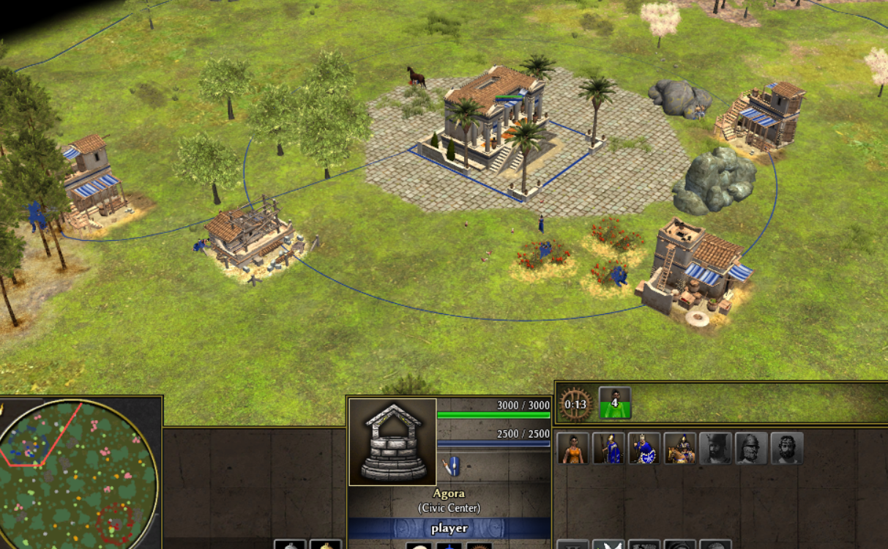

Bad: Floating resources, idle units, long walking distances men collecting berries, women mining, housed, training one by one in queues. Also no wood gathering.
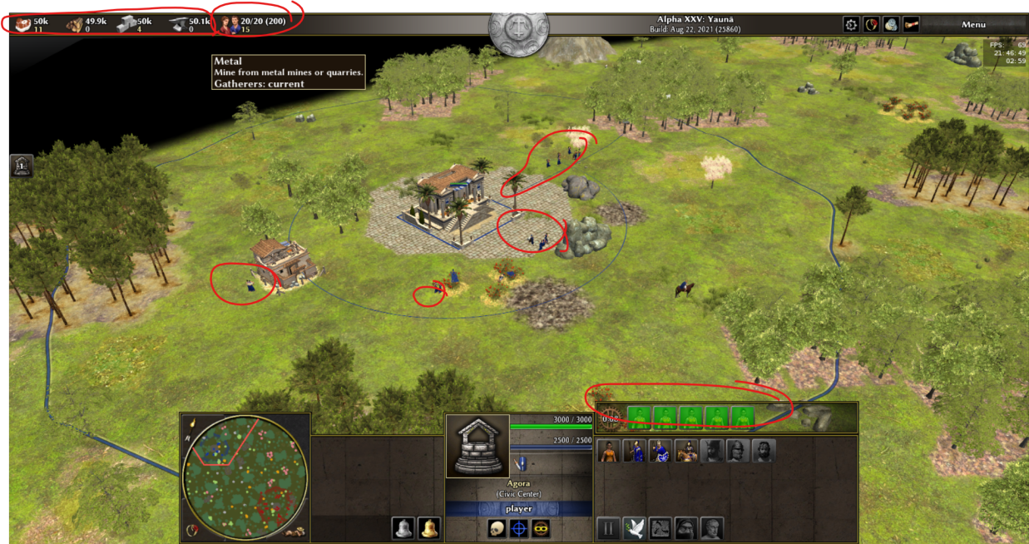

Hardware settings
Sometimes using the correct game settings can give you an advantage. But this is mostly up to you to decide what is comfortable for you. However, there are a few things I highly recommend:
The game time and ceasefire time indicators turned on.
- Unit silhouettes turned on.
- Shadows set to low or off.
- Batch size to 1.
The Autociv mod by nani is very handy for multiplayer, as it can display the number of each type of units you have and the number of kills you scored.
Here are screenshots of my settings:
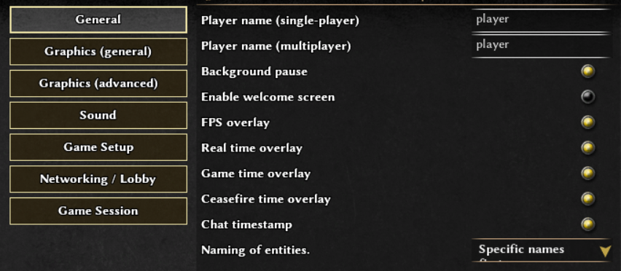
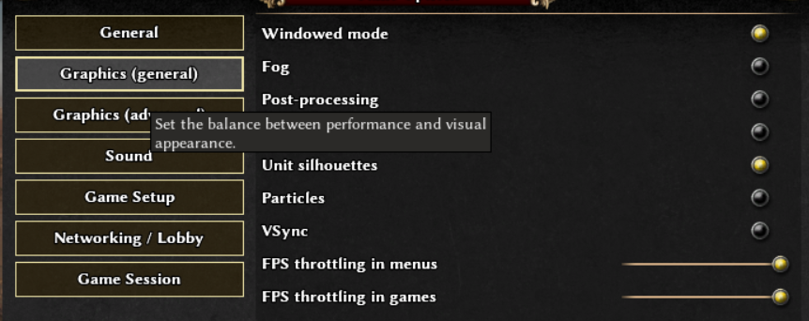
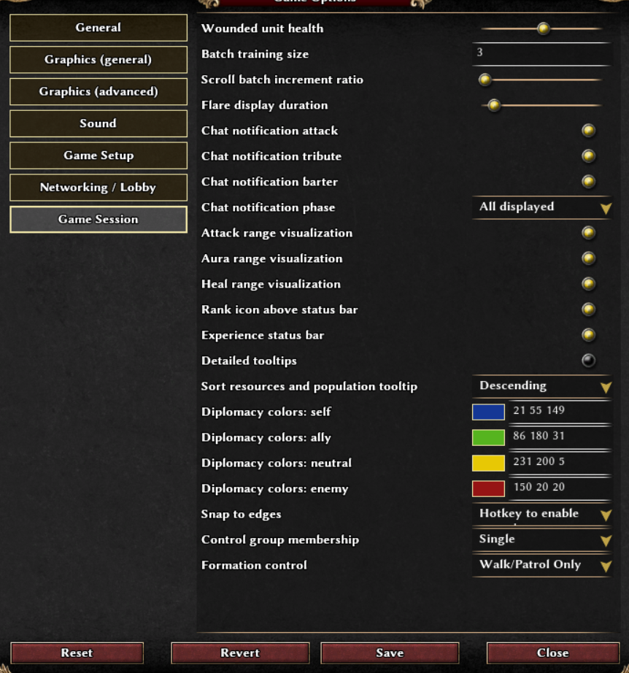

General tips

Scouting and vision: this is incredibly important against humans as you must know what your enemy is up to in order to respond appropriately. Vision can be obtained in many ways, from making your cavalry unit walk around in your enemy’s base to building outposts around their territory. In early game, you can use your ranged units to explore near your base to determine what resources are there to exploit, e.g. berries, extra metal, hunt. Outposts can be build at where your enemy must come through to attack you, e.g. the centre of the map; a canyon; somewhere with many mines. You can also send your cavalry to scout your enemy’s base after it finishes gathering chickens. If you see them having many cavalry units or have a stable build already, then you can expect a rush. If you see mostly women then they are booming and you are safe from rushes, but you may consider rushing them if you see some concentration of soft targets.

Picking the right opponent: if you are new in the lobby, you might consider picking an opponent who has a similar skill to you for 1v1 games ( less than 1200 rating). You can learn something from them (hopefully) and they won’t destroy you instantly. But once you are not cosmic, don’t just play with others who are weaker than you to accumulate your rating, that is stupid. Play with people of similar level or slightly higher level than you, until you are 1400-1500, by which point you are ready to join TGs. Nicely convince the host to not kick you.

Unit combinations: it is important to consider your military composition as well as economic forces. When fighting, suppose you can field 120 units to a single fight, these 120 units should consist of ranged inf, melee inf and some cavalry. Generally, 1:1 ranged to melee can’t go too wrong, but there are certain combinations that are especially strong:
Cavalry javelineer + any melee infantry in 2:3 ratio
Infantry pikeman + infantry javelineer in 1:2 ratio.
For Ptolemies: slingers + pikemen with Cleopatra hero, in 5:2 ratio.
For Spartans: 30 Skiritai commandos + the rest is all infantry javelineers + Brasidas.
Also Spartans: All hoplite army or half hoplite half javelineer, both with Leonidas hero.

Civilisation choices. Before you play a game, I recommend studying the structure tree and unit trees for each civilisation, as well as descriptions of their team bonus. This allows you know what each civ has to offer so you can make more informed decisions in the TGs. It is also recommended to get yourself familiar with one civ first, then try out new ones over time. Civs which are easy to play for beginners are Spartans, Romans, Gauls and Iberians, because they don’t have complicated unit tree so are quite easy to get familiar with. Some civs require more practice and skill than others, but are very OP once you get used to them, for example Ptolemies, Seleucids, Carthaginians, Kushites, Macedonians. When choosing a civ in a TG, consider your team bonus and your teammate’s choice. Some civ combinations can offer you a very good advantage:

Ptolemies + Iberians + Spartans + Romans. Iber, Spart, Rome are javelin civs; iber gives them a cost discount, Rome gives everyone a train time reduction; Spartans boost the spearmen of everyone, and Ptolemies give you a free food trickle for smoother boom. So the 3 of you can field very strong javelin + spear infantry armies while the Ptolemies player does their own slinger + pike.

Ptolemies + Kushites + Seleucids + Mauryas. Kushites give elephant discount and all 4 of these are elephant civs, so everyone can end up with large mighty elephant army that is completely unstoppable. On top of this, Seleucids have elephant hero that +20% attack to their war elephants; Mauryan elephants train 30% faster. Meanwhile, Mauryas themselves offer a cheap temple bonus, which combined with Seleucid cheaper civic structure bonus allows you to construct CCs and temples everywhere at ease and heal up any wounded units near enemy base.

