The Council is both happy and proud to announce a special new release!!!

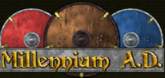

What is it?
Millennium A.D. is a total conversion mod for 0 A.D. focusing on the Middle Ages. It is divided in two parts, this first one is focusing on the first half of the Middle Ages; the timeframe of Charlemagne and the Viking Age. The name of this release is Xýlo. This is a byzantine word for wood, in recognition for vanilla 0AD’s founder (https://play0ad.com/new-release-0-a-d-alpha-23-ken-wood/ ). That is respectful for the new release

What is new?
Thanks to Alexandermb talented modder is responsible for majority of the new models, Wackyserious our versatile texture artist, Stanislas69 our artist and Lion.Kanzen icon and texture artist, we are happy to introduce you to two new civilizations Byzantines and Carolingians as well as Anglo-Saxons and Norse faction are updated this release.

Byzantines
The mighty civilization which has its roots in Eastern Roman Empire dawns this release.
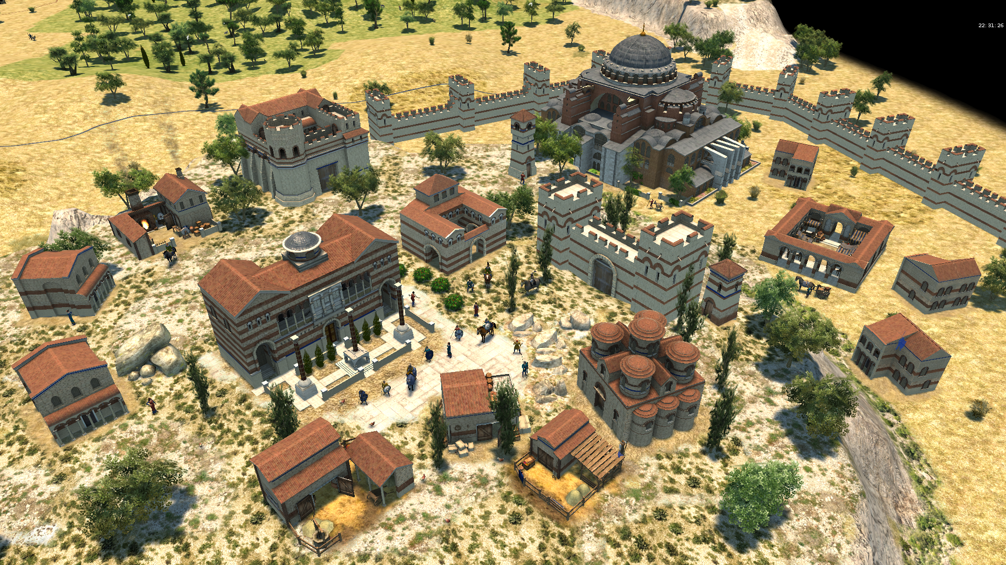

This release Byzantines got new market, variation of houses, corral, blacksmith, civ centre and many other buildings. Also Byzantines use new units and ships including fire ships.
Carolingians
The time of Charlemagne has come and you will witness the might of his Franks.
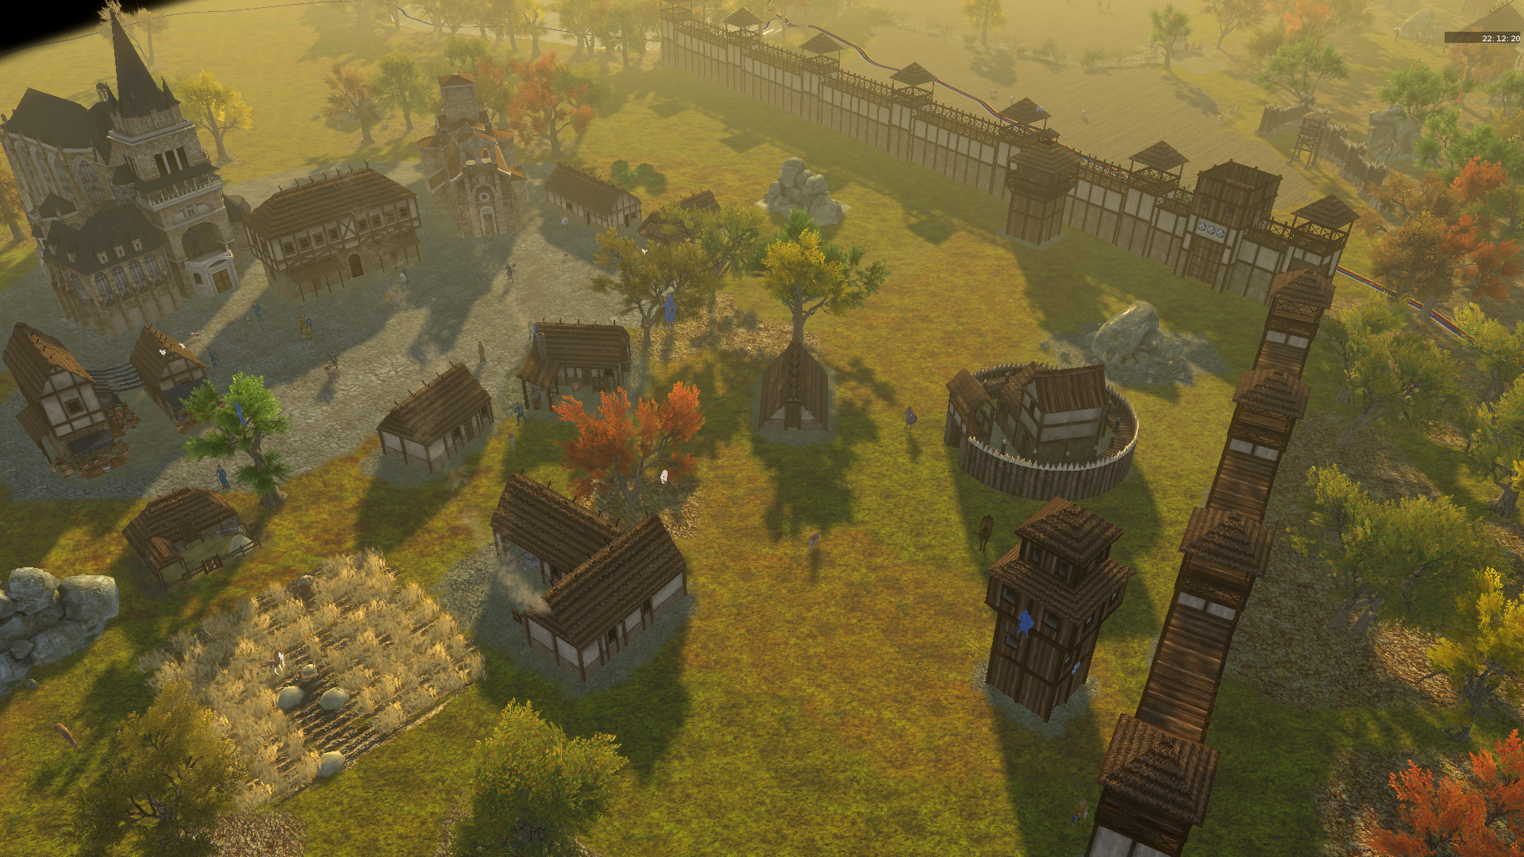
Last release Carolingians were hidden and worked on by Stanislas69 and this release thanks to fully redone building set and remodelled units are available. You can look forward to Cathedral of Aachen and Carolingian church or docks. From units we can mention Catholic priest.
Anglo-Saxons
This release Anglo-Saxons got Bixworth church(wonder) enabled and Offa of Mercia as their hero that together with his axeman will break through the lines of defence.
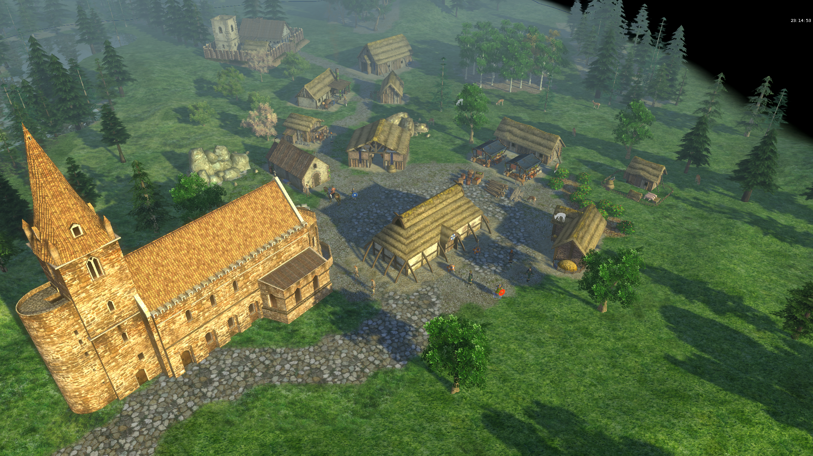
The Norse
Prepare for the new naval battles with the Norse. Since last release the Norse got new longboats and ships are fully animated.

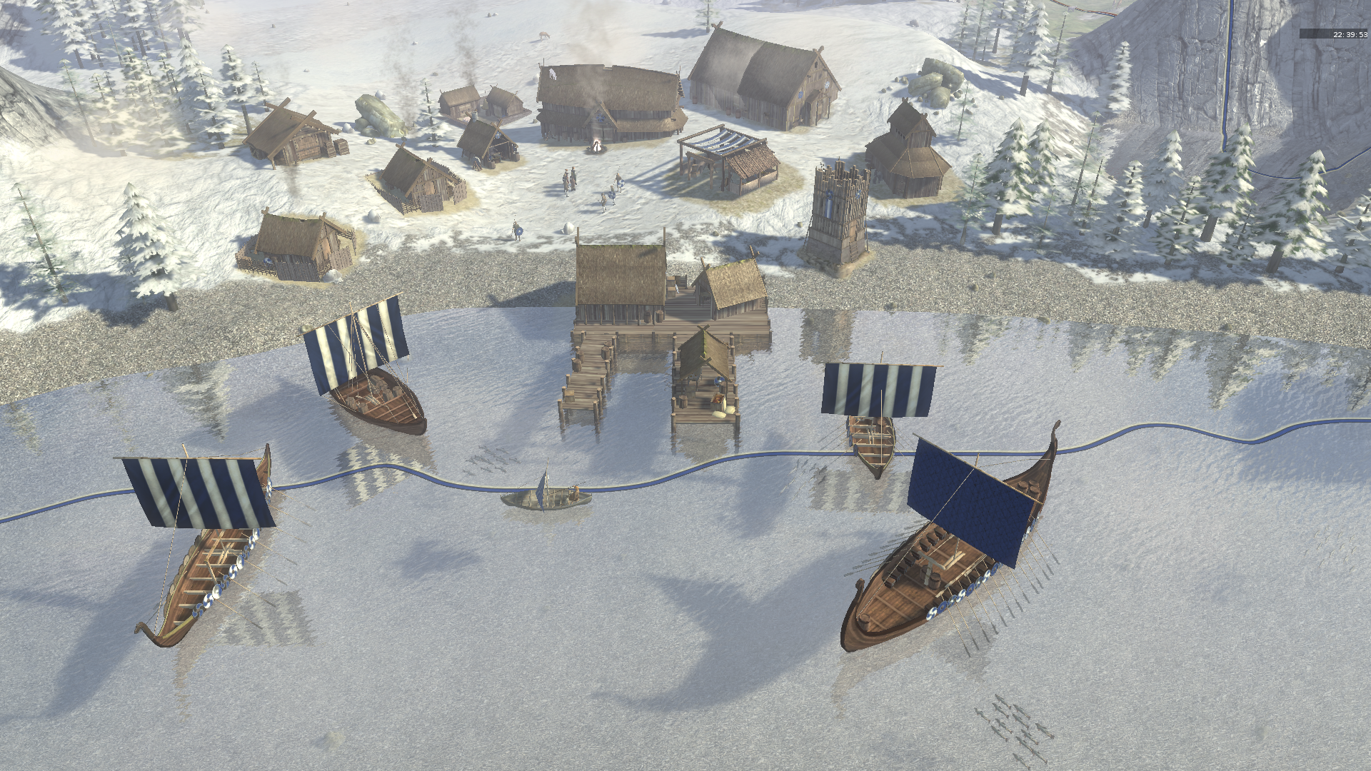

Many smaller changes were made in this release too, but it would be too elaborate to list them all.
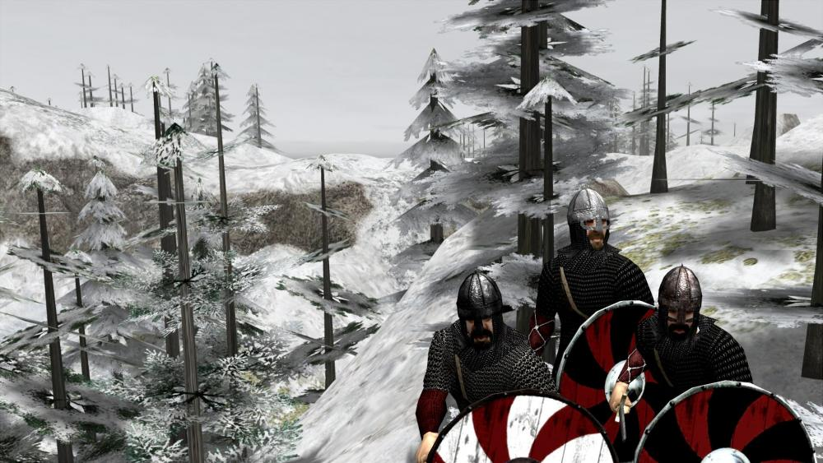

Who are we?
The Council of Modders was formed up of two small modding teams and a few newcomers: Aristeia (about the bronze age),Millennium A.D. (about medieval times), Rise of the East (East civilizations, Current Terra Magna) and Ponies Ascendant (Pony factions) CoM aims to create a umbrella for all wannabee modders and help everyone needed and of course create their own projects.

How to:
- Unzip the download but leave the inner archive intact.
- Place the unzipped folder into /binaries/data/mods. You'll see another folder there called 'public'.
- Launch the game and enable the mod in Options>Mod Selection. Press 'Start Mods'.
- Enjoy the mod!

Download:

ModIO installation:
- Main menu -> Configuration -> Mods -> Download -> doubleclick

Pyromod installation:
- Download pyromod file, open with pyrogenesis.exe

In the last few years some members retired leaving us shorthanded. We are currently especially in the need of artists. So if you're a talented artist with a passion for history and you would like to help us out, please contact us using a PM or (preferably) in this thread: Wildfiregames...showtopic=18412 Thanks in advance!
Our thanks go to everyone that helped us to achieve this mod through contributing, playtesting or in another way!
If you have tips / suggestions, feel free to let us know. Also if you find bugs, let them know too. Support 0 A.D. if you like us: Play0ad.com
The main menu background is made by Alexlinde from Deviantart. You can find him here: Alexlinde.deviantart.com
The soundtracks are created by Antti Martikainen. You can find more of his work here: Anttimartikainen.bandcamp.com and Youtube.com

